**Activity 7 - Ring-based deployment**

**Roll no: 20K-0409**

Using Existing Project : **Agile Planning**

**Screen Shots**

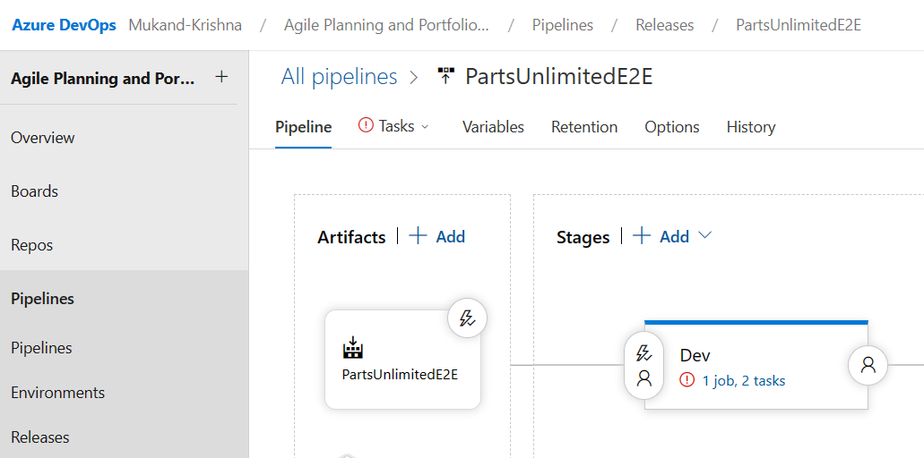

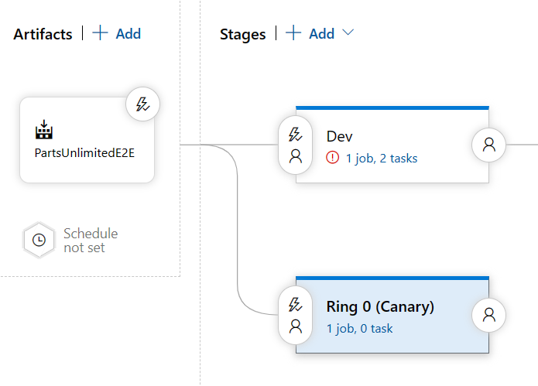

**2 and 3**

**4, 5, and 6:**

**7.: Variable automatically imported**

**8 and 9**

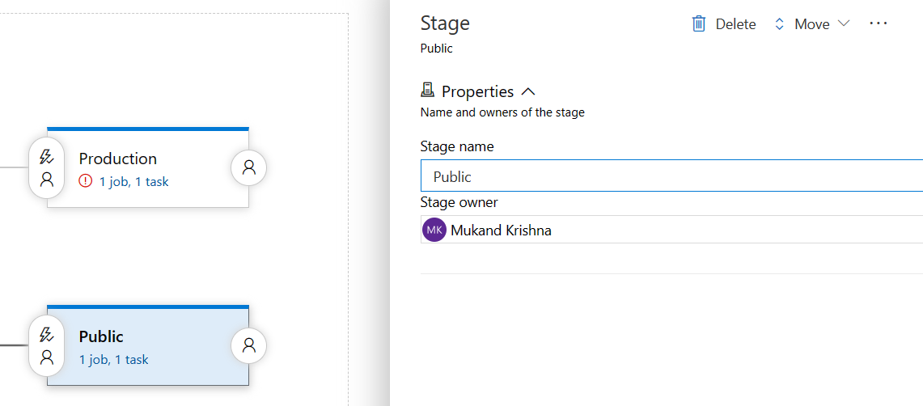**10.**

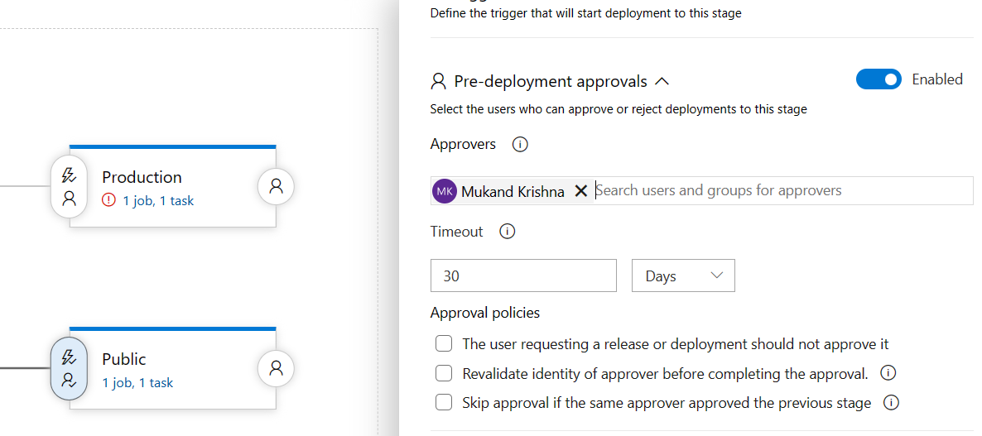**11.**

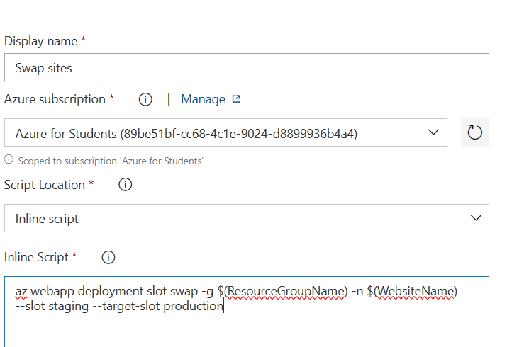**12.**

**13.**

**Run Pipeline :**

**14.**

**15. Error came:**

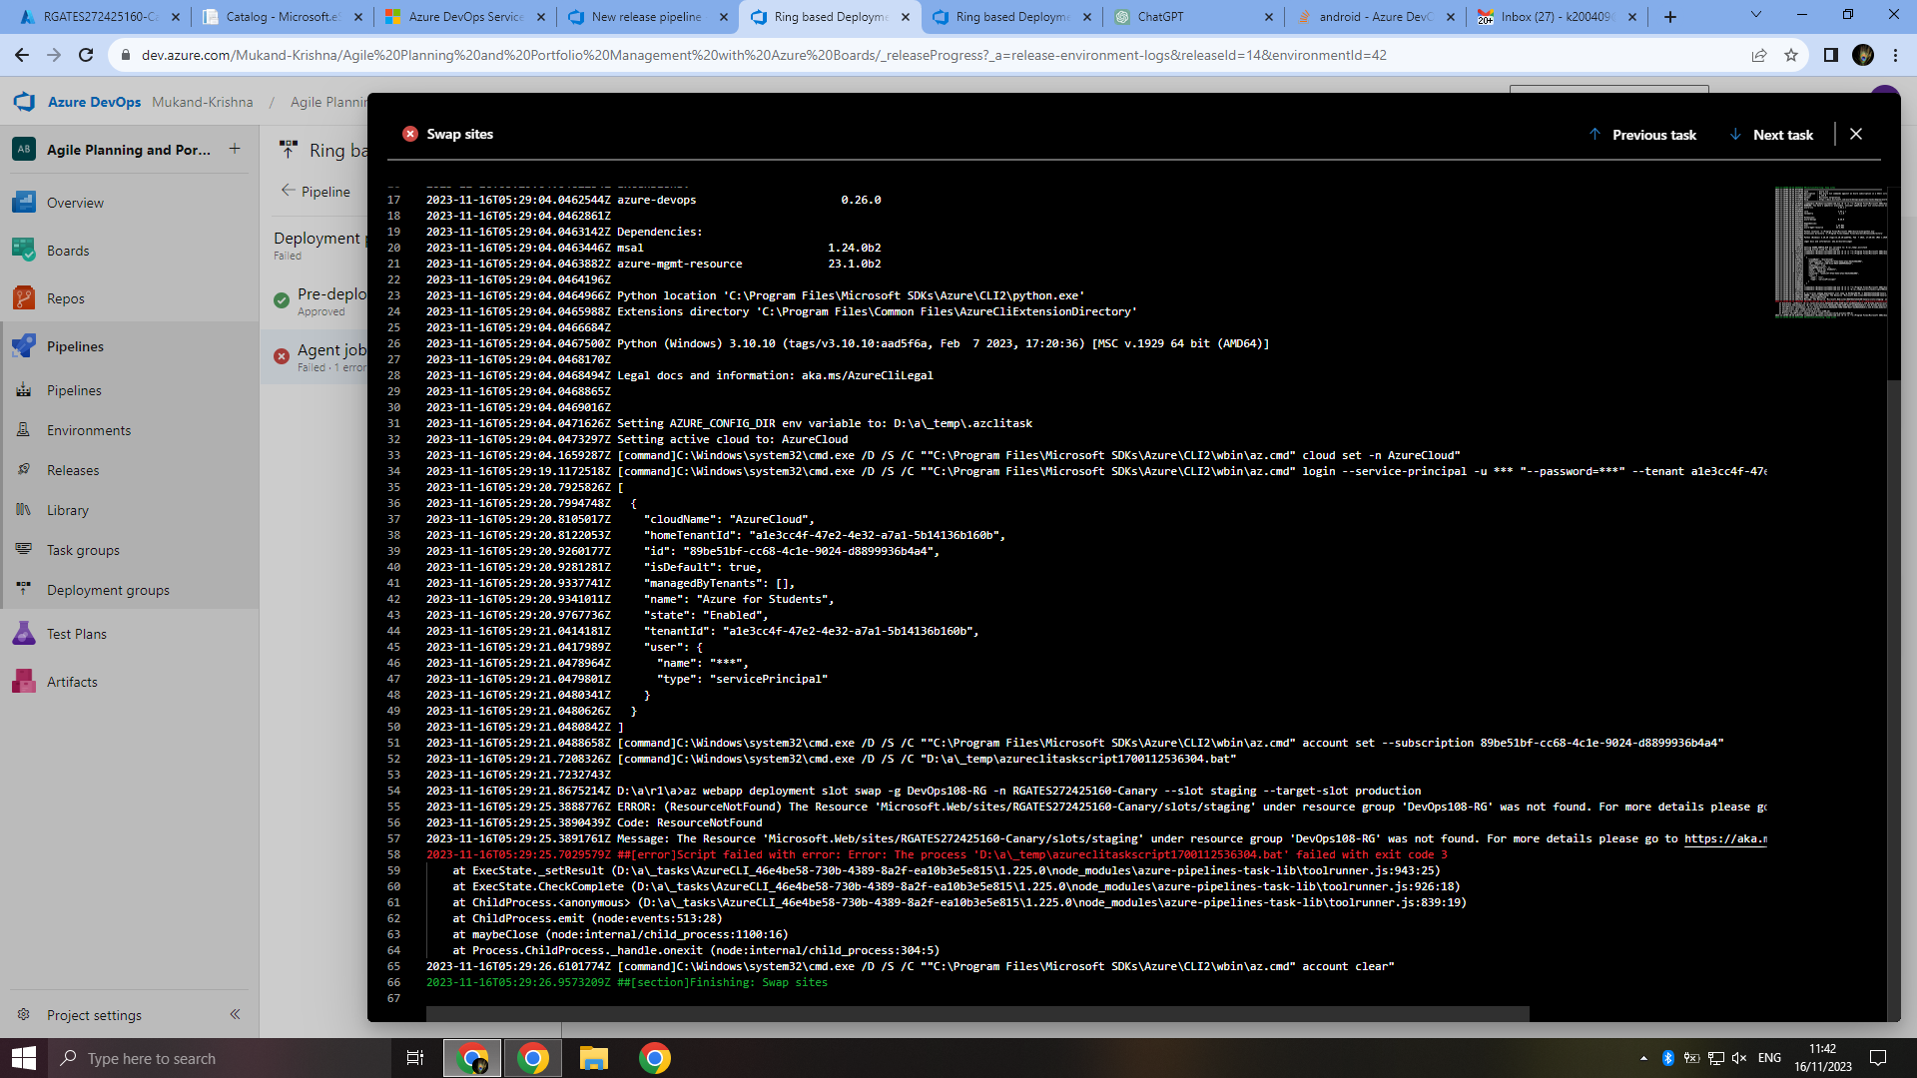

**16. After adding deployment slot in azure portal, worked**

